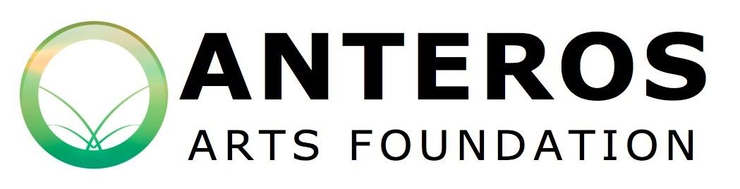
Anyone with connections in Norfolk, Suffolk and Cambridgeshire may apply to exhibit at Anteros.
The Anteros Curation Committee is responsible for selecting the exhibitions that take place at
Anteros Arts Foundation.
The committee comprises of management staff and a trustee representative and meetings take place every two to three months depending on number of applications.

Together the committee assess applications using the following criteria:
Will the artwork sell?
Will the artist or artworks bring new audiences to Anteros?
Will the show benefit a school or educational organisation?
Could an informational experience be delivered alongside this show?
(examples: practical workshop, lecture, written guide/trail, meet the artist)
What effect will this show have on Anteros’ reputation?

​In the view of the committee, applications must answer yes to at least one, preferably two of the first four questions listed above.

Please return your application form to our Gallery Manager via email: gallery@anterosfoundation.com or by post: 7-15 Fye Bridge St. Norwich, NR3 1LJ.

Contact Full Name:
Preferred Name:
Address:
Post Code:
Phone Number:
Email:
Telephone number:
Website and/or social media tags:

Which gallery do you wish to book:

Name of your exhibition:

How will you be marketing/advertising your exhibition?

Excess on insurance is £250. Will you be taking out insurance on your artwork worth less than £250?
Yes No

If yes, please provide details of your insurer, their address and policy number:

Please answer the following questions, in no more than 200 words per question:

What is the medium of artwork to be shown?

How would you describe your style of artwork?

Where would you say your inspiration has come from?

When did you create the work to be shown in the exhibition?

What does your artwork mean to you?

Are you able to incorporate an informational element to this exhibition, eg. An artist’s talk/practical workshop/family trail? If so, please give details.

Please detail how you will make best use of the space.

Let us know what fixings/attachments/plinths you will need before you turn up on hanging day. (Please discuss with the gallery what is possible before completing this question)

Please attach any image/s of your artwork or links, as well as any supporting documents for how you would like to utilise the gallery space.

