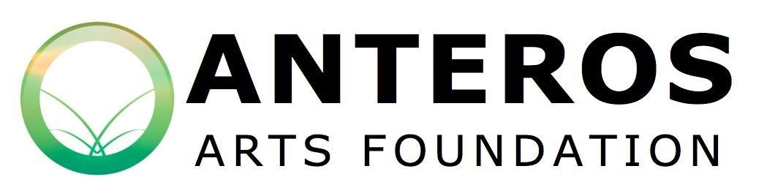

Application Form
Group Exhibition

Anyone with connections in Norfolk, Suffolk and Cambridgeshire may apply to exhibit at Anteros.
Staff work closely with local artists to enable them to present a professional standard exhibition, we can offer additional support to those who need it. Anteros can offer additional support through help with both physical and digital marketing, hanging artwork, curating the exhibition and more. The gallery actively celebrates diversity, promotes equality, tackles discrimination and fosters equal opportunities.

The Curation Committee is responsible for selecting the exhibitions that take place at
Anteros Arts Foundation.

Criteria:
Will the artwork sell?
Will the artist or artworks bring new audiences to Anteros?
Will the show benefit a school or educational organisation?
Could an informational experience be delivered alongside this show?
(examples: practical workshop, lecture, written guide/trail, meet the artist)
What effect will this show have on Anteros’ reputation?

​In the view of the committee, applications must answer yes to at least one, preferably two of the first four questions listed above.

Primary Contact Full Name:
Preferred Name:

Address:
Post Code:

Phone Number:
Email:

Website:
Social media used:

In which gallery would you like to hold your show:
Main Gallery: Front Gallery:

What is your preferred time of year?

Please answer the following questions (200 words per question max):

What do you call yourselves as a collective?

What is the title of the exhibition?

Please also give the names of each artist in the collective including links to website/social media:

When did your group or collective form; and what brought your collective together?

What unifies the work in this proposed exhibition? (Eg. Is it the media, techniques or abstract themes?)

What is the medium of artwork to be shown?

Where would you say your inspiration has come from?

When did you create the work to be shown in the exhibition?

Are you able to incorporate an informational element to this exhibition, eg. An artist’s talk/practical workshop/family trail/meet the artist? If so, please give details.

How will you be marketing/advertising your exhibition?

Please give an idea of the price range you are selling at, with an example of the lowest and the highest pricing. Please be aware that the Anteros Arts Gallery operates primarily as a cultural resource for the local community and very expensive artworks may be less likely to find a buyer here.

The Anteros Arts Foundation does not intend for the cost of hire to present a barrier to exhibitors. If the cost of hire cannot be met, please give details and let us know how much you might be able to pay towards the ongoing maintenance of our gallery spaces and staffing costs:

Please detail how you will make best use of the space including any information on the fixings/attachments/plinths needed: (You are encouraged to discuss with the gallery what is possible before completing this part of the form)

The excess on our insurance policy is £250. This will not be covered by the Gallery in case of a claim. Will you be taking out insurance on your artwork to cover this?

If yes, please provide details of your insurer, their address and policy number:
Yes No

Please attach images of your artwork or links, as well as any supporting documents for how you would like to utilise the gallery space.

It is a fundamental principle of all Anteros Arts Foundation policies that all people are equally valued regardless of their race, colour, nationality, ethnic origin, national origin, religion, belief, gender, marital/civil partner status, sexual orientation, gender reassignment, age, disability, trade union membership and part/fixed-term employment status. It would therefore assist us greatly in monitoring our recruitment process if you would also complete an equal opportunities monitoring form and return this separately to joella@anterosfoundation.com. This form may be found on the website at www.anterosfoundation.com/exhibit-at-anteros

Please email your application form to our gallery manager: gallery@anterosfoundation.com
Or post to: 11 - 15 Fye Bridge Street, Norwich, NR3 1LJ

