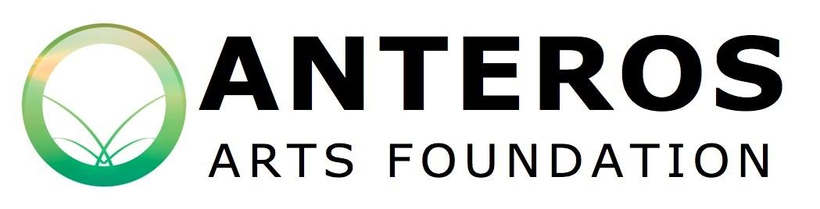Anteros Arts Foundation Course Booking Form
Please return the completed form by Post to Anteros Arts Foundation,
11-15 Fye Bridge St, Norwich NR3 1LJ or via email at courses@anterosfoundation.com

Please note: you're place is not secured until payment is received. Payment can be made via Paypal on the website, BACS (Co-Operative charity account: 65388602 Sort Code: 089299), cheque, or card. Please indicate which method of payment you've used when returning your booking form. Price: as per website
Name of the course you would like to book: ................................................................................
Form of Payment: ...........................................................................................................................
Personal Details
Full Name: ......................................................................................................................................
Address: …………………………………………………………………………………………………………………………………….
Email: ………………………………………………………………………………………………………………………………………..
Phone number: ...............................................................................................................................
Are there any adjustments we can make to our course or accompanying literature which would make the day more manageable for you? ……………………………………………………………………………………
Do you have any health conditions which tutors might need to be aware of? (please note, you are welcome to telephone Anteros to discuss if you prefer. All booking forms are confidential, see privacy note below).

Would you like to be added to our mailing list to hear more details about upcoming courses?
(Please tick as appropriate) Yes No
How did you hear about the course? ……………………………………………………………………………………………………………………………………………………

Next of Kin
Please give us details of whom we should contact in case of emergency:
Full Name: .......................................................................................................
Relationship: ....................................................................................................
Daytime Contact number: ...............................................................................
Mobile: .............................................................................................................
Photography Consent
We would like to take photos/film and/or comments of you (as applicable) as a record of events and for promotional purposes. These images may appear on our website and email newsletters, in our printed materials produced for promotional purposes including leaflets, posters and adverts, in materials sent out to the media, or in reports to funding bodies. We will not include personal e-mail or postal addresses, or telephone or fax numbers on our website or in printed publications. Please note that websites can be seen throughout the world, and not just in the United Kingdom, where UK law applies.
To comply with the Data Protection Act 1998, we need your permission before we take any photographs/film of you.
Conditions of use
- This form is valid for five years.
- We will not use the photographs/film for any other purposes than those mentioned above.
- We will not include personal details (such as postal addresses, or telephone number) on our website, printed materials or other marketing/promotional materials.
- Copyright of photographs taken will remain with the Anteros Arts Foundation.

Do you give us permission? (Please tick as appropriate) Yes No
I confirm the accuracy of the information detailed in this application and I agree should there be any changes to the information provided, I will notify Anteros Arts Foundation as soon as practicable. I agree to Anteros Arts Foundation storing the personal data contained in this form in accordance with Data Protection Act (1998) until the course is finished.
Date and Signature:
Privacy Notice: personal and sensitive data about course participants is collected, controlled and processed by the Anteros Arts Foundation in order to comply with our policies and legal obligations pertaining to safeguarding and health and safety. We will not keep more information than we need on record for any longer than is strictly necessary. We will not share or sell your details with any third parties. Should a breach in our data protection systems occur, and should your personal data be compromised in a way which may pose a risk to your rights or freedoms you will be notified immediately. To view our full data protection policy, please request a copy by emailing: flik@anterosfoundation.com

