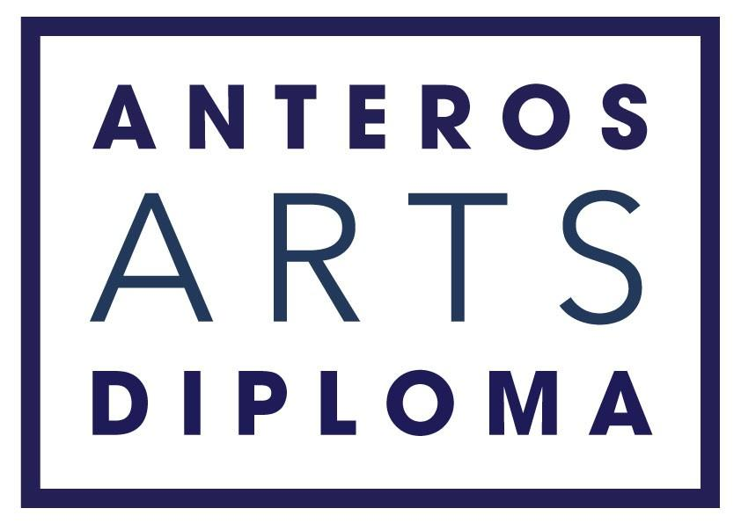

Application pack

ABOUT THE COURSE

The Anteros Arts Diploma is a skills-based fine art course that takes place between September and April. It includes modules in drawing, painting, photography, printmaking, sculpture and art theory. There is also a module called ‘community art’ through which you will gain experience in professionalism, collaboration and outreach. During the course you will benefit from 4 one to one tutorials with a senior tutor on the course, in order to help you foster and grow your individual style.

Studio space is provided for the duration of the course with access to a press, fine art reference library, and wifi.

The course offers the opportunity to exhibit work: there will be an exhibition of Final Major Pieces plus preparatory work in the Main Gallery at Anteros in April 2022.

ABOUT ANTEROS ARTS FOUNDATION

Anteros is a charity which aims to strengthen and support the community in Norwich by supporting artists and improving access to the arts.

As a charity we aim:
- to offer quality fine art courses for beginners and improvers.
‐ to exhibit a diverse and varied selection of fine art exhibitions by local artists.
‐ to program high quality music events.
‐ to strive to offer opportunities for learning alongside our concerts and exhibitions.
‐ to maintain a grade II* listed building and keep it open to the public.

We have nine years’ experience offering high quality short courses in drawing, painting, printmaking, sculpture and art history. The Anteros Diploma represents a natural progression in the Foundation’s development as an educational establishment of outstanding merit.

The Anteros Arts Diploma takes place from September to April and draws together fine art skills from across the disciplines offering students a city-central studio space with access to a printing press, wifi and an art reference library.

Learn practical skills
Learn practical fine art skills in drawing, painting, printmaking and sculpture. There is also the opportunity to practice presentation, teaching and networking skills through our community module, which aims to engage students to start thinking about the various elements of an ongoing art practice.

Exhibit with us
During the course you will have the opportunity to make and curate an exhibition; an end-of-year exhibition in the Main Gallery, showcasing your final major piece and the preparatory work which led up to it.

Be part of our community
Our unique community module will encourage you to be more outward looking and help you form the links with other arts organizations in Norwich through volunteering. As well as branching out into the creative community, we encourage you to form ties with your fellow students through peer-to-peer learning and sharing ideas outside of lesson time.

City central studio space
Included in the price of the diploma is a city central studio space that is shared only with your fellow diploma students. This will be available for you to use when you start the course in September until your exhibition in April.

Create a body of work
The Anteros Diploma is not an accredited award but we can guarantee that students will come away having learned useful skills and with a full portfolio of work. For alumni students this has been enough to gain a place on a fine art MA!

Making time to make
The course commitment is approximately 8 hours per week. That’s 8 hours of structured teaching time. We believe these hours will offer robust stepping stones towards a technically competent portfolio and will generate enough ideas to get you working in your studio and from home in between times. We also hope that it offers enough time outside of the diploma for important work and family commitments.

Stay focused
When you enroll you will be given some pointers in the art of sketchbooking to help you document your journey and inspiration. You will also be appointed a tutor who will meet with you four times during the course, to review your growing portfolio and help you plan your Final Major Piece for the April exhibition.

COURSE REQUIREMENTS
To achieve the Anteros Diploma you will not have to take any written exams, your certificate will be awarded based on your involvement in two exhibitions and on attendance and participation.

Attendance & Participation
-­‐ You must attend 80% of your printmaking, sculpture, and art history, painting and drawing tuition.
-­‐ You must complete 100% of your Community Module.
-­‐ You must attend three tutorials with your given tutor.
-­‐ You must attend and contribute to seminars
-- You must produce a piece for us to give away in our annual fundraising Art Raffle

Exhibiting
-­‐ You must take part in the Final Exhibition in April.
-­‐ You must complete a Final Major Piece for the April Exhibition in your own time. This is the only piece of work you are required to do outside of tutored hours, although continuing practice is strongly encouraged.

-­‐-­‐-­‐-­‐-­‐-­‐-­‐-­‐-­‐-­‐-­‐-­‐-­‐-­‐-­‐-­‐-­‐-­‐-­‐-­‐-­‐-­‐-­‐-­‐-­‐-­‐-­‐-­‐-­‐-­‐-­‐-­‐-­‐-­‐-­‐-­‐-­‐-­‐-­‐-­‐-­‐-­‐-­‐-­‐-­‐-­‐-­‐-­‐-­‐-­‐-­‐-­‐-­‐-­‐-­‐-­‐-­‐-­‐-­‐-­‐-­‐-­‐-­‐-­‐-­‐-­‐-­‐-­‐-­‐-­‐-­‐-­‐-­‐-­‐-­‐-­‐-­‐-­‐-­‐-­‐-­‐-­‐-­‐-­‐-­‐-­‐-­‐-­‐-­‐-­‐-­‐-­‐-­‐-­‐-­‐-­‐-­‐-­‐-­‐-­‐-­‐-­‐-­‐-­‐-­‐-­‐

FEES

Total Course Fee £2400

A 33% deposit £800 is taken when your place is awarded. The remainder can be paid in 8 installments of £200 by direct debit at the start of each month.

At each stage the installments are non-refundable, if a student chooses to leave the course they must give four weeks notice and no charges will be incurred for educational events taking place after this notice period.

If you would like to discuss the diploma further, please don’t hesitate to contact us.

enquiries@anteros.co.uk / 01603 766 129

www.anterosfoundation.com

The Anteros Arts Diploma is a course which takes place over 8 months. It draws together fine art skills from across the disciplines and offers students a city-central studio space with access to printing presses and an art reference library.

Application Form

Please return the completed form by post to Anteros Arts Foundation, 11-15 Fye Bridge St, Norwich NR3 1LJ or email to courses@anterosfoundation.com

Applicants will be selected on the basis of their answers to the three free-word questions starting on page 3. Course facilitators are looking for evidence of diligence and commitment. Anteros aims to process your application as quickly as possible and will give you a response within 3 weeks of your application.

The Anteros Arts Foundation is licensed to store data securely and in accordance with the data protection act by the ICO. The information below is requested to help ensure that your experience on the diploma is safe and pleasurable. Your details will not be shared either with the tutors employed by Anteros, or with any third parties without your informed consent.

Personal Details

Full Name:

Preferred Name:

Date of birth: ...... /...... /.......
Address:
Post Code: Town: .
Phone number:

Email address:

Health Problems and/or Disabilities

Please let us know if you have any health problems and/or disabilities so we can make all reasonable adjustments to help you (this information will remain strictly confidential).

Food allergies/ Dietary

Next of Kin

Please give us details of whom we should contact in case of emergency:

Full Name:
.
Relationship:

Daytime Contact number:

Mobile:

Have you applied for a bursary position? Yes / No

Can you only undertake the course if awarded a bursary position? Yes / No

Do you have any criminal convictions or charges pending?

The following DO NOT need reporting:
- A motoring offence for which you received a fine or three penalty points;
- A spent sentence (as defined by the Rehabilitation of Offenders Act 1974)
Yes / No If yes, we will contact you for further information and to discuss

How did you hear about Anteros Art Diploma?

I confirm the accuracy of the information detailed in this application and I agree should there be any changes to the information provided, I will notify Anteros Arts Foundation as soon as practicable.

I agree to Anteros Arts Foundation using the personal data contained in this form for any purposes connected to this course, health and safety under the Data Protection Act (1998).

Date and Signature:

................................................................................

- Please introduce yourself in a brief statement (background, studies, current job, any relevant paid or unpaid experiences?)

- Please set out your reasons for undertaking this course. (250 words maximum)

- Please tell us what you would like to gain from this experience (250 words maximum)

