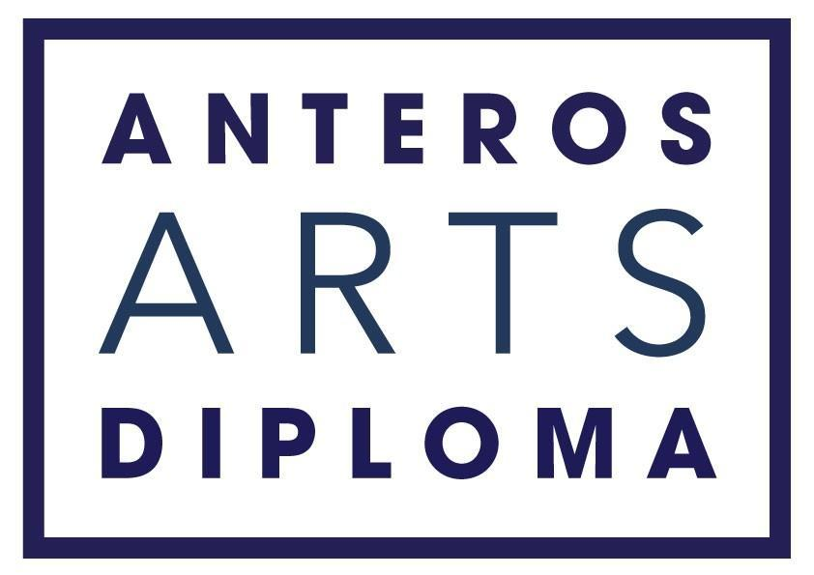

Application Pack

SUMMARY

ABOUT THE COURSE

The Anteros Arts Diploma is a skills-based fine art course that takes place between September and May. It includes modules in drawing, painting, photography, printmaking, 3D art and art theory.

Studio space is provided for the duration of the course with access to a press, fine art reference library, and wifi.

The course offers the opportunity to exhibit work: there will be an exhibition of Final Major Pieces plus preparatory work in the Main Gallery at Anteros in May 2023.

ABOUT ANTEROS ARTS FOUNDATION

Anteros is a charity which aims to strengthen and support the community in Norwich by supporting artists and improving access to the arts.

As a charity we aim:
- To offer quality fine art courses for all levels of practice
- To exhibit a diverse and varied selection of fine art exhibitions that are free to enter and reasonably priced for artists
- To programme high quality music events at affordable prices
- To strive, where possible, to offer opportunities for learning alongside our exhibitions
- To promote social inclusion through the arts by providing ​a safe, informative and friendly place to visit
- To maintain a grade II* listed building and keep it open to the public
- To offer opportunities to engage with art for all ages

THE COURSE

In a city centre studio space and classroom, the Anteros Arts Diploma draws together fine art skills from across the disciplines which equips students with a portfolio of work which they can use to further their art education or hone in on where they’d like to focus. With reflective practice and regular crits students will develop their work, culminating in an exhibition in the Main Gallery.

Learn practical skills
Learn practical fine art skills in drawing, painting, printmaking and photography.

Exhibit with us
During the course you will have the opportunity to make and curate an exhibition; an end-of-year exhibition in the Main Gallery, showcasing your final major piece and the preparatory work which led up to it.

Visit with us
During the course you will have guided visits to both the Castle Museum and the Sainsburys Centre to widen your practice and understanding of art. You will also have the opportunity to see a regularly changing exhibition programme at Anteros itself, a unique opportunity to see different mediums of art and how exhibitions are curated in different ways.

City central studio space
Included in the price of the diploma is a city central studio space that is shared only with your fellow diploma students. This will be available for you to use when you start the course in September until your exhibition in May.

Create a portfolio
The Anteros Diploma is not an accredited award but we can guarantee that students will come away having learned useful skills and with a full portfolio of work. For alumni students this has been enough to gain a place on a fine art MA!

Making time to make
The course commitment is approximately 11 hours per week teaching time over two days. We believe these hours will offer robust stepping stones towards a technically competent portfolio and will generate enough ideas to get you working in your studio and from home in between times. Teaching days are Friday and Saturday. Some time working on projects at home is expected, although studio time is built in to the teaching hours to help with this.

Practice reflectively
When you enroll you will be given some pointers in the art of sketchbooking and reflective journaling to help you document your journey and inspiration. Alongside regular crit sessions, you will be supported in developing your art practice to where you’d like to take it.

COURSE REQUIREMENTS
To achieve the Anteros Diploma you will not have to take any written exams, your certificate will be awarded based on your involvement in the exhibition and on attendance and participation.

Attendance & Participation
-­‐ You must attend 80% of your classes.
-­‐ You must attend and contribute to seminars
-- You must produce a piece for us to give away in our annual fundraising Art Raffle

Exhibiting
-­‐ You must take part in the Final Exhibition curation, including preparing artists statements, labels and getting work ready for hanging
-­‐ You must complete a Final Major Piece for the Exhibition

-­‐-­‐-­‐-­‐-­‐-­‐-­‐-­‐-­‐-­‐-­‐-­‐-­‐-­‐-­‐-­‐-­‐-­‐-­‐-­‐-­‐-­‐-­‐-­‐-­‐-­‐-­‐-­‐-­‐-­‐-­‐-­‐-­‐-­‐-­‐-­‐-­‐-­‐-­‐-­‐-­‐-­‐-­‐-­‐-­‐-­‐-­‐-­‐-­‐-­‐-­‐-­‐-­‐-­‐-­‐-­‐-­‐-­‐-­‐-­‐-­‐-­‐-­‐-­‐-­‐-­‐-­‐-­‐-­‐-­‐-­‐-­‐-­‐-­‐-­‐-­‐-­‐-­‐-­‐-­‐-­‐-­‐-­‐-­‐-­‐-­‐-­‐-­‐-­‐-­‐-­‐-­‐-­‐-­‐-­‐-­‐-­‐-­‐-­‐-­‐-­‐-­‐-­‐-­‐-­‐-­‐

FEES

Total Course Fee £2400

A 33% deposit £800 is taken when your place is awarded. The remainder can be paid in 8 installments of £200 by direct debit at the start of each month.

At each stage the installments are non-refundable, if a student chooses to leave the course they must give four weeks notice and no charges will be incurred for educational events taking place after this notice period.

If you would like to discuss the diploma further, please don’t hesitate to contact us.

enquiries@anteros.co.uk / 01603 766 129

www.anterosfoundation.com

The Anteros Arts Diploma is a course which takes place over 8 months. It draws together fine art skills from across the disciplines and offers students a city-central studio space.

Application Form

Please return the completed form by post to Anteros Arts Foundation, 11-15 Fye Bridge St, Norwich NR3 1LJ or email to manager@anterosfoundation.com

Applicants will be selected on the basis of their answers to the three free-word questions starting on page 3. Course facilitators are looking for evidence of diligence and commitment. Anteros aims to process your application as quickly as possible and will give you a response within 3 weeks of your application.

The Anteros Arts Foundation is licensed to store data securely and in accordance with the data protection act by the ICO. The information below is requested to help ensure that your experience on the diploma is safe and pleasurable. Your details will not be shared either with the tutors employed by Anteros, or with any third parties without your informed consent.

Personal Details

Full Name:

Preferred Name:

Date of birth: ...... /...... /.......
Address:
Post Code: Town: .
Phone number:

Email address:

Health Problems and/or Disabilities

Please let us know if you have any health problems and/or disabilities so we can make all reasonable adjustments to help you (this information will remain strictly confidential).

Food allergies/ Dietary

Next of Kin

Please give us details of whom we should contact in case of emergency:

Full Name:
.
Relationship:

Daytime Contact number:

Mobile:

Have you applied for a bursary position? Yes / No

Can you only undertake the course if awarded a bursary position? Yes / No

Do you have any criminal convictions or charges pending?

The following DO NOT need reporting:
- A motoring offence for which you received a fine or three penalty points;
- A spent sentence (as defined by the Rehabilitation of Offenders Act 1974)
Yes / No If yes, we will contact you for further information and to discuss

How did you hear about Anteros Art Diploma?

I confirm the accuracy of the information detailed in this application and I agree should there be any changes to the information provided, I will notify Anteros Arts Foundation as soon as practicable.

I agree to Anteros Arts Foundation using the personal data contained in this form for any purposes connected to this course, health and safety under the Data Protection Act (1998).

Date and Signature:

................................................................................

- Please introduce yourself in a brief statement (background, studies, current job, any relevant paid or unpaid experiences?)

- Please set out your reasons for undertaking this course. (250 words maximum)

- Please tell us what you would like to gain from this experience (250 words maximum)

